Common Instructions for all the exam versions
You are required to develop a complete Single Page Application using HTML, CSS & JavaScript. The application must use the assigned DummyJSON API and dynamically display the returned data. Do not hardcode API data inside JavaScript. The application must follow the provided desktop and mobile wireframe.
1. Common UI wireframe you should follow
Follow the provided desktop and mobile wireframes for the overall layout. You may choose your own colors, typography, spacing, and visual styling.
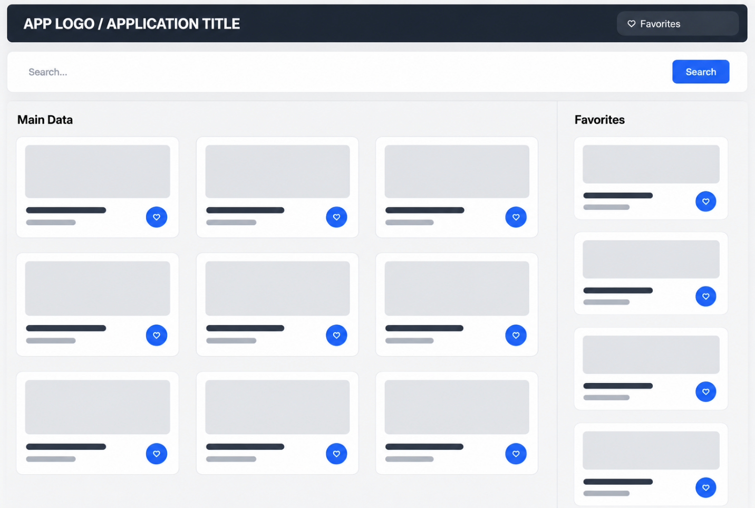
Figure 1: Desktop Version
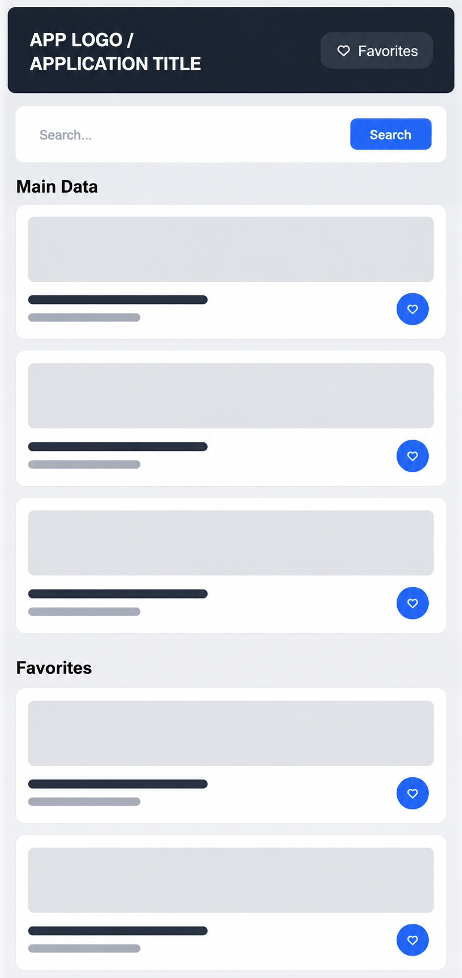
Figure 2: Mobile Version
2. Required Implementation Steps (Hint)
- Create the HTML structure using semantic elements such as header, main, section and footer.
- Create a responsive UI using CSS Grid/Flexbox and media queries.
- Create one state object containing the fetched data, saved items, and search state. Follow the expected state structure provided for your version.
- Fetch the assigned API using fetch() with async/await.
- Handle loading and errors using try/catch. Treat an unsuccessful HTTP response as an error (for example, by checking response.ok).
- Render the cards dynamically using map() and template literals.
- Implement live search using filter() on the already-fetched data. Do not request the API again when the user searches.
- Implement the required saved-item collection with add and remove functionality.
- Persist the required saved-item collection using localStorage with JSON.stringify() and JSON.parse().
- Initialize the app using an init() function that loads saved data, fetches API and renders page.

3. Marking Criteria (100 marks)

Criteria | Marks
Semantic HTML structure | 10
Responsive CSS design | 15
Fetch API with async/await | 15
State object implementation | 10
Dynamic rendering using map() | 15
Search using filter() | 10
Favorites add/remove functionality | 10
Local Storage persistence | 10
Loading & error handling | 5
Code readability and organization | 5
Finishing and Deployment | 50
Total | 150

4. Important Rules
- Use only HTML, CSS and vanilla JavaScript (Module 2 contents).
- Data must come from the assigned DummyJSON API using fetch().
- The required saved items must remain after page refresh using localStorage.
- Search must work on the already-fetched data using filter(); do not fetch the API again while searching.
- The application must be responsive on mobile and desktop using CSS Grid/Flexbox and media queries.
- You may use search engines and technical resources such as Google, MDN, JavaScript/CSS documentation, and Stack Overflow. You should understand and be able to explain any code you use.

